**Movie Analysis & Recommendation**

**Dataset Used : MovieLens dataset**

**-SENTHIL RAMASAMY(2013103602)**

**-SANJANA JAIN(2013103601)**

**The raw data set was of the form:**

## Character Encoding

The three data files are encoded as [UTF-8](http://en.wikipedia.org/wiki/Utf-8).

## User Ids

* Movielens users were selected at random for inclusion. Their ids have been anonymized.
* Users were selected separately for inclusion in the ratings and tags data sets, which implies that user ids may appear in one set but not the other.
* The anonymized values are consistent between the ratings and tags data files. That is, user id n, if it appears in both files, refers to the same real MovieLens user.

## Ratings Data File Structure

* All ratings are contained in the file ratings.dat. Each line of this file represents one rating of one movie by one user, and has the following format:
* UserID::MovieID::Rating::Timestamp
* The lines within this file are ordered first by UserID, then, within user, by MovieID.
* Ratings are made on a 5-star scale, with half-star increments.
* Timestamps represent seconds since midnight Coordinated Universal Time (UTC) of January 1, 1970.

## Tags Data File Structure

* All tags are contained in the file tags.dat. Each line of this file represents one tag applied to one movie by one user, and has the following format:
* UserID::MovieID::Tag::Timestamp
* The lines within this file are ordered first by UserID, then, within user, by MovieID.
* Tags are user generated metadata about movies. Each tag is typically a single word, or short phrase. The meaning, value and purpose of a particular tag is determined by each user.
* Timestamps represent seconds since midnight Coordinated Universal Time (UTC) of January 1, 1970.

## Movies Data File Structure

* Movie information is contained in the file movies.dat. Each line of this file represents one movie, and has the following format:
* MovieID::Title::Genres
* MovieID is the real MovieLens id.
* Movie titles, by policy, should be entered identically to those found in [IMDB](http://www.imdb.com/), including year of release. However, they are entered manually, so errors and inconsistencies may exist.

Genres are a pipe-separated list, and are selected from the following:

* Action
* Adventure
* Animation
* Children's
* Comedy
* Crime
* Documentary
* Drama
* Fantasy
* Film-Noir
* Horror
* Musical
* Mystery
* Romance
* Sci-Fi
* Thriller
* War
* Western

**GOALS ACHIEVED:**

* To explore the MovieLens dataset for trends with movie preferences
* To become better exploring data with R
* To demonstrate an example statistical exploratory analysis project from raw data to report

**Analysis Done:**

* Investigating general data set:

**Age Plot**

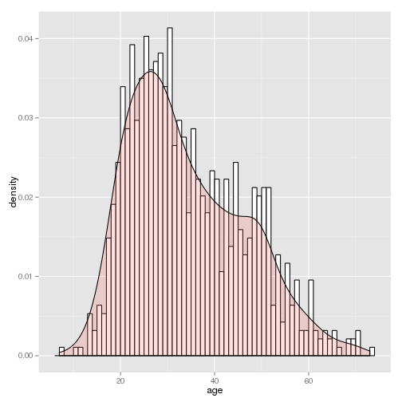

**Code:**

|  |
| --- |
| mlDat_user <- ddply(mlDat, ~user_id + age + gender + occupation, summarize, mean_rating = mean(rating))  agePlot <- ggplot(mlDat_user, aes(age)) + geom_histogram(aes(y=..density..), binwidth=1, colour="black", fill="white")  agePlot <- agePlot + geom_density(alpha=.2, fill="#FF6666")  print(agePlot)  ggsave(filename = "agePlot.jpg") |

**Observation:**

Users tend to be mostly in the late teens and mid thirties, though there seems to be another peak the occurs in the late forties.

**Movies Date Plot:**

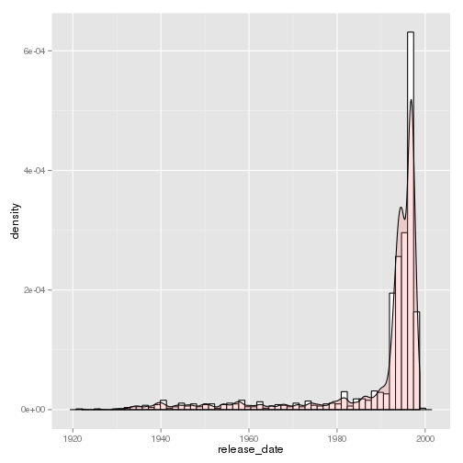

**Observation:**

Most movies in the data tend to be from the 1990's. There is a pretty long tale meaning they have at least some moves from the past.

**Code Snippet:**

|  |
| --- |
| mlDat_movie <- ddply(mlDat, ~movie_title + release_date + genre, summarize, mean_rating = mean(rating))  datesPlot <- ggplot(mlDat_movie, aes(release_date)) + geom_histogram(aes(y=..density..), binwidth=500, colour="black", fill="white")  #alter axis  datesPlot <- datesPlot + geom_density(alpha=.2, fill="#FF6666")  print(datesPlot)  ggsave(filename = "datesPlot.jpg") |

**Investigate the users with respect to profession that contributed to the dataset**

* Total numbers of each profession that contributed to the dataset
* Gender bias in each profession
* How the professions tend to rank movies

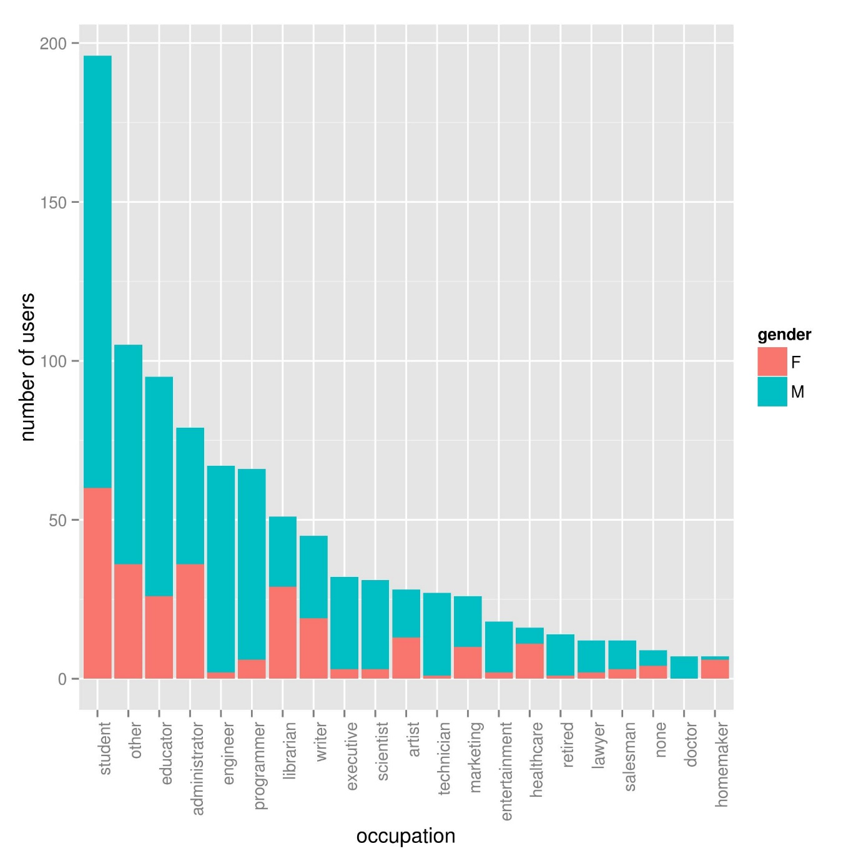

Code Snippet:

|  |
| --- |
| #Profession based analysis block block graph  #sorts by number of users  userPlot <- ggplot(mlDat_user, aes(x=reorder(occupation,occupation,  function(x)-length(x)), fill = gender)) + geom_bar()  #fix axis  userPlot <- userPlot + theme(axis.text.x = element_text(angle = 90, hjust = 1))  userPlot <- userPlot + ylab("number of users") + xlab("occupation")  #flip axis to make professions easier to read  #userPlot <- userPlot + coord_flip()  ggsave(filename = "userPlot.jpg") |

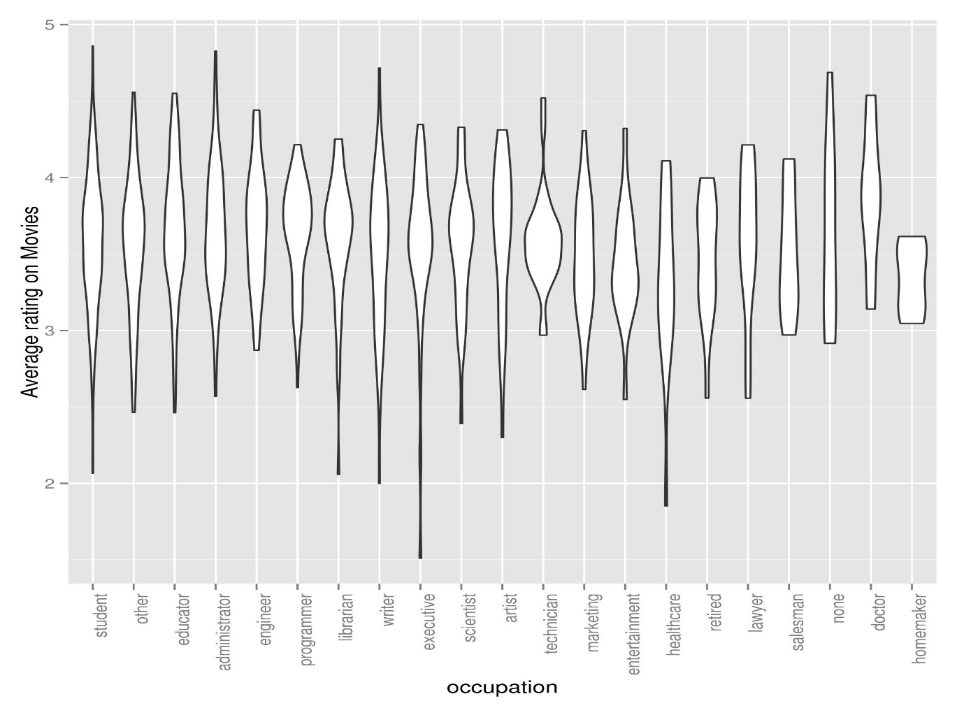

Code Snippet:

|  |
| --- |
| rankPlot <- ggplot(mlDat_user, aes(x=reorder(occupation,occupation,  function(x)-length(x)), mean_rating)) + geom_violin()  #fix axis  rankPlot <- rankPlot + theme(axis.text.x = element_text(angle = 90, hjust = 1))  rankPlot <- rankPlot + ylab("Average rating on Movies") + xlab("occupation")  #flip axis to make professions easier to read  #rankPlot <- rankPlot + coord_flip()  ggsave(filename = "rankPlot.jpg") |

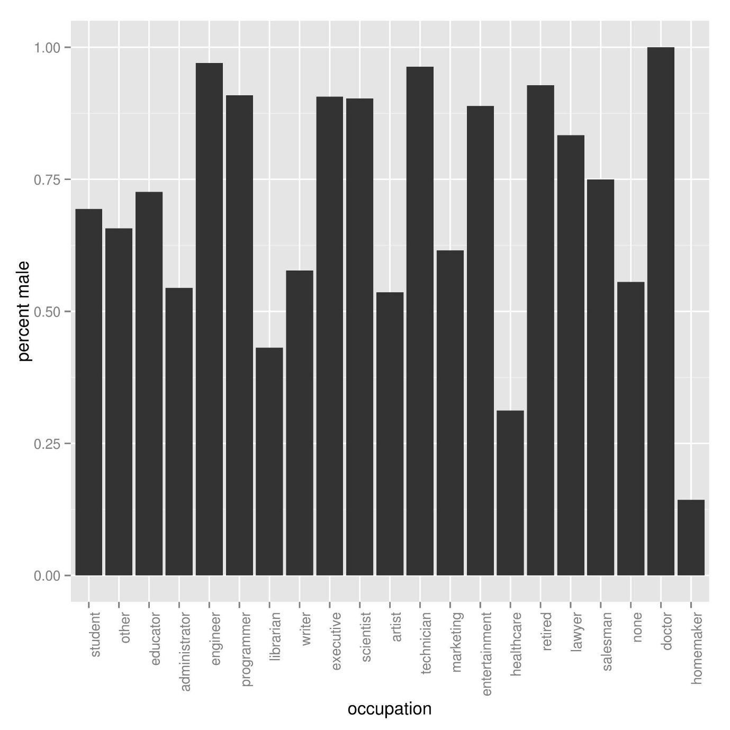

**Code Snippet:**

|  |
| --- |
| gender_dat <- ddply(mlDat_user, ~occupation, summarize, perc_male = (length(gender[gender == "M"])/length(gender)), counts = -length(user_id))  #sorts by number of users  genderPlot <- ggplot(gender_dat, aes(x=reorder(occupation, counts), perc_male)) + geom_bar(stat="identity")  #fix axis  genderPlot <- genderPlot + theme(axis.text.x = element_text(angle = 90, hjust = 1))  genderPlot <- genderPlot + ylab("percent male") + xlab("occupation")  #flip axis to make professions easier to read  #genderPlot <- genderPlot + coord_flip()  ggsave(filename = "genderPlot.jpg") |

**Observations:**

* There are very few doctors and homemakers, we probably can't say anything about these groups with very much confidence
* Males make up of more of our sample. Some professions like engineering (rather unsurprisingly) are completely male dominated.
* The professions do not rank things evenly. Some appear more picky; for example executives seem to sometime rank movies very low and healthcare workers seem to have a very low average rating.

## Investigate the movies with respect to users in the dataset

**Observation:**

A majority of the titles are multi genre. There really does not seem to be an even spread of titles, for example there are almost no pure fantasy titles.

**Code Snippet:**

|  |
| --- |
| genreCountPlot <- ggplot(mlDat_movie, aes(x=reorder(genre,genre,  function(x)-length(x)))) + geom_bar()  #fix axis  genreCountPlot <- genreCountPlot + theme(axis.text.x = element_text(angle = 90, hjust = 1))  genreCountPlot <- genreCountPlot + ylab("number of movies") + xlab("genre")  genreCountPlot <- genreCountPlot + coord_flip()  print(genreCountPlot)  ggsave(filename = "genreCountPlot.jpg") |

**Total number of movies with a specific genre counted multiple times for multi genre movies:** 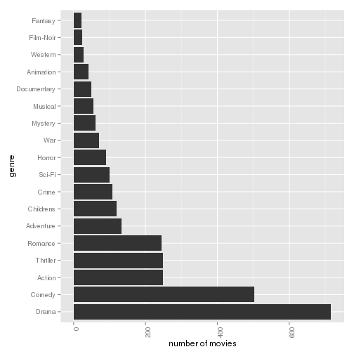

**Code Snippet:**

|  |
| --- |
| mlDat_movie_multi <- ddply(mlDat_multi, ~movie_title + release_date + genre, summarize, mean_rating = mean(rating))  genreCountPlot_multi <- ggplot(mlDat_movie_multi, aes(x=reorder(genre,genre,  function(x)-length(x)))) + geom_bar()  #fix axis  genreCountPlot_multi <- genreCountPlot_multi + theme(axis.text.x = element_text(angle = 90, hjust = 1))  genreCountPlot_multi <- genreCountPlot_multi + ylab("number of movies") + xlab("genre")  genreCountPlot_multi <- genreCountPlot_multi + coord_flip()  print(genreCountPlot_multi)  ggsave(filename = "genreCountPlot_multi.jpg") |

## Investigate the trends in movies with respect to rating and other factors within the dataset

#### Does genre affect the rating of a movie? Does genre matter to the average male or female?

## Pure Genre:

## 

## Observation:

## Noir and Animation seem to be the highest rated surprisingly. Low sample sizes for some of these is a problem; the only reason fantasy and war seem like they make a difference in terms of gender is that the sample size for both is quite small. The only gender differnce I notice is maybe the fact that women seem to like musicals more than men.

## Multiple Genres:

## 

The low sample sizes seem to be fixed. Things noticed:

* Horror movies do not get good ratings. It fits my expectations since horror movies tend to typically focused on cheap thrills but are not typically impactful.
* There are very few fantasy films and they tend to rank low. It could be that no one wants to take risks on making these types of movies because of this.

## Investigate trends in profession with respect to movie genre preference

## 

## Code Snippet:

|  |
| --- |
| mlDat_genre_occup <- ddply(mlDat, ~genre + occupation, summarize, mean_rating = mean(rating))  mlDat_genre_occup <- droplevels(subset(mlDat_genre_occup, occupation != "homemaker"))  mlDat_genre_occup <- droplevels(subset(mlDat_genre_occup, genre != "unknown"))  mlDat_genre_occup <- droplevels(subset(mlDat_genre_occup, genre != "Fantasy"))  mlDat_genre_occup <- droplevels(subset(mlDat_genre_occup, occupation != "none"))  mlDat_genre_occup <- droplevels(subset(mlDat_genre_occup, genre != "War"))  mlDat_genre_occup <- droplevels(subset(mlDat_genre_occup, occupation != "doctor"))  heatMapPalette <- colorRampPalette(rev(brewer.pal(4, "RdBu")))  #get data ready for heatmap  goHeat <- ggplot(mlDat_genre_occup, aes(x = genre, y = occupation, fill = mean_rating))  #rotate labels  goHeat <- goHeat + geom_tile() + theme(axis.text.x = element_text(angle = 90, hjust = 1))  #add colours  goHeat <- goHeat + scale_fill_gradientn(colours = heatMapPalette(100))  #change background  goHeat <- goHeat + theme(panel.background = element_rect(fill='black'),  panel.grid.major = element_blank(),  panel.grid.minor = element_blank())  print(goHeat)  ggsave(filename = "genreOccupHeatMap.jpg") |

Note: Black tiles are missing data.

So now I'm noticing some other interesting trends:

* The retired (and likely elderly) do not like pure crime movies. Maybe they prefer not to think about what crimes could happen.
* People who work in healthcare (not doctors) have extremely high standards.
* Executives tend to dislike many movie genres but still like noir films.
* Lawyers like noir and romance films. ( DON’T KNOW WHY :P )
* Many more - do you see anything interesting?

Note: Some professions are underrepresented (for instance there are only 7 doctors in this dataset who also happen to be male). Also, Pooling together multiple genre movies greatly reduced possible the sample sizes for genres. Finally, the division point (white colour) is placed on roughly a rating of 3 but people tend to rank movies more than 3 on average.